Azure cloud documentations:

How to authenticate azure resources?

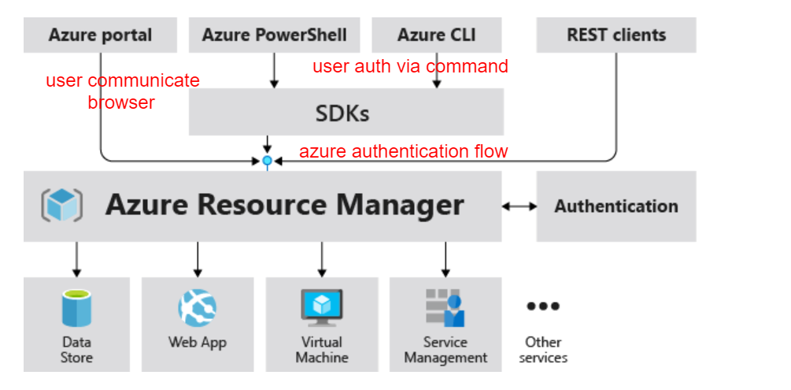

## Benefits of Resource Manager

* resource - A manageable item that is available through Azure. Virtual machines, storage accounts, web apps, databases, and virtual networks are examples of resources.
* resource group - A container that holds related resources for an Azure solution. The resource group includes those resources that you want to manage as a group.
* resource provider - A service that supplies Azure resources.
* Resource Manager template - A JavaScript Object Notation (JSON) file that defines one or more resources to deploy to a resource group or subscription
* declarative syntax - Syntax that lets you state "Here is what I intend to create" without having to write the sequence of programming commands to create it.

Scope:

Azure provides four levels of scope:

1. Management groups,
2. Subscriptions
3. Resource groups
4. Resources

Flow of azure to use azure resources

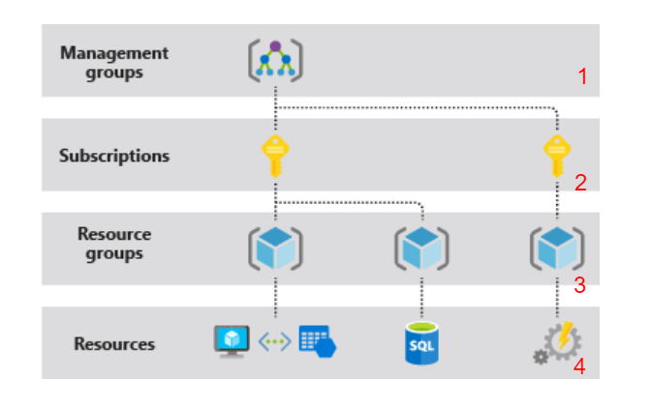

Azure Resource Manager

Azure Resource Manager is the deployment and management service for Azure. It provides a management layer that enables you to create, update, and delete resources in your Azure subscription. You use management features, like access control, locks, and tags, to secure and organize your resources after deployment.

Resource Group:

A container that holds related resources for an Azure solution. The resource group includes those resources that you want to manage as a group.

Resource group factors:

* All the resources in your group should share the same lifecycle. You deploy, update, and delete them together. If one resource, such as a database server, needs to exist on a different deployment cycle it should be in another resource group.
* Each resource can only exist in one resource group.
* You can add or remove a resource to a resource group at any time.
* You can move a resource from one resource group to another group.
* A resource group can contain resources that are located in different regions.
* A resource group can be used to scope access control for administrative actions.
* A resource can interact with resources in other resource groups. This interaction is common when the two resources are related but don't share the same lifecycle (for example, web apps connecting to a database).

How to create resource group

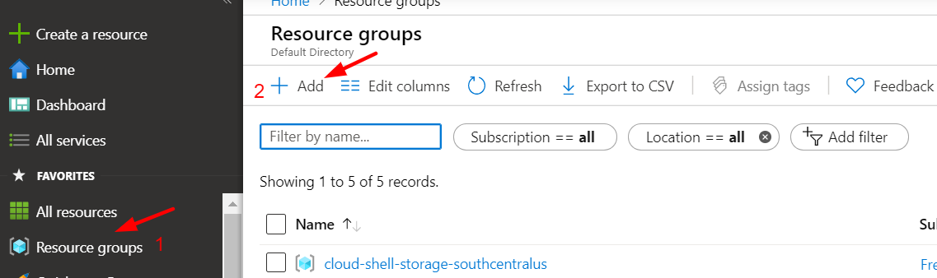

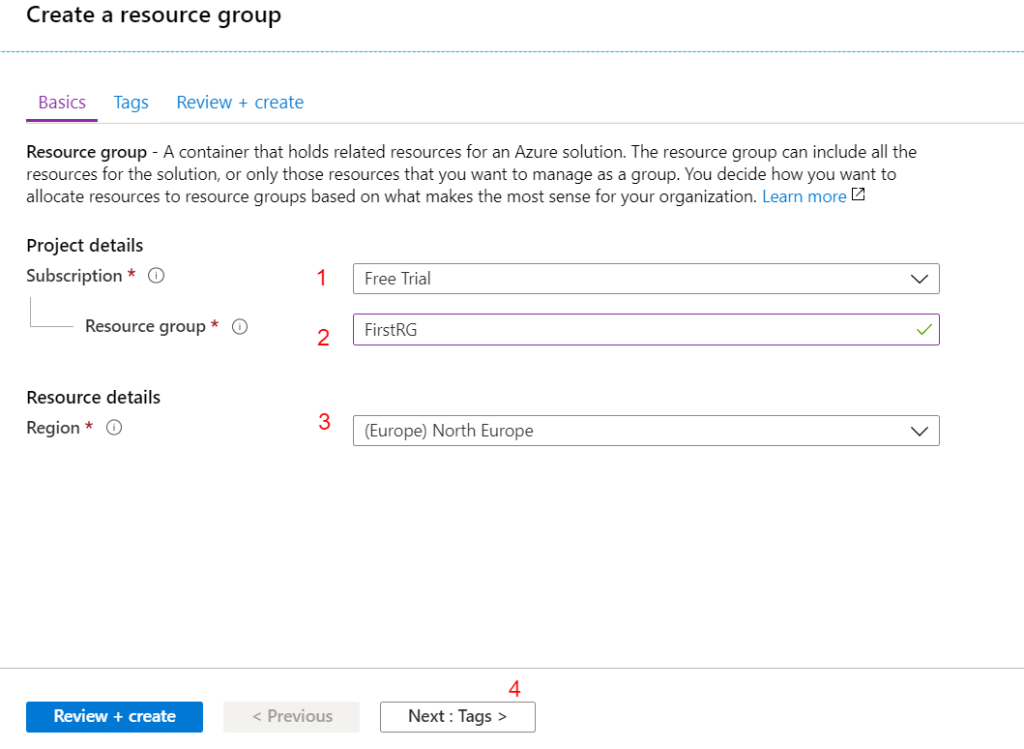

1. - Select your subscription ID
2. - Set Resource group Name
3. - Select your Region
4. - To set Tags
5. - To set tag values. Value contains key and value pair
6. - Review
7. - validate
8. - finally create

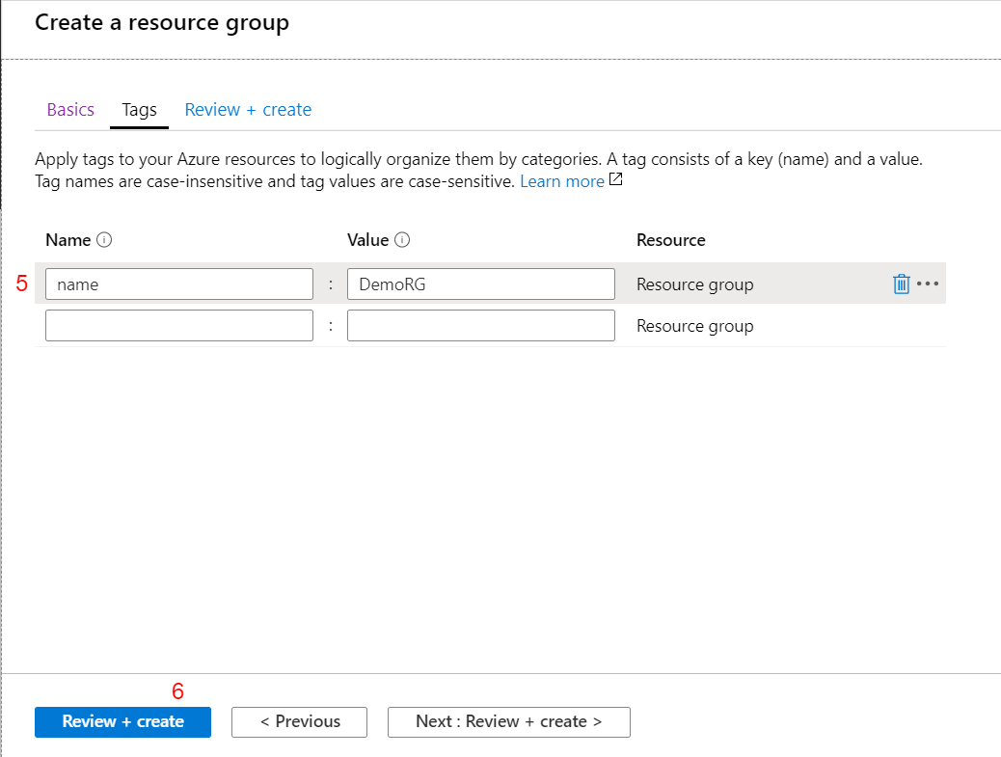

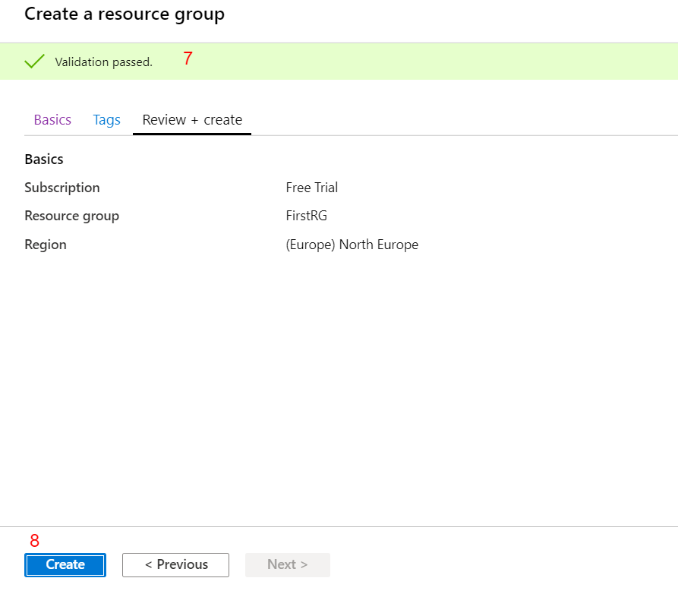

Verify the Resource Group

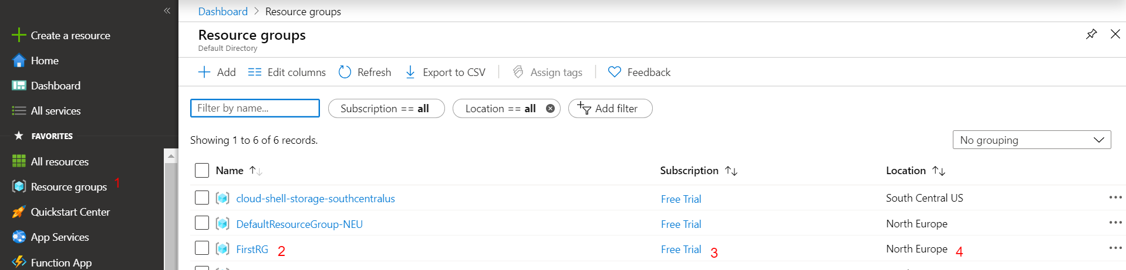

All details reflect into your resource group

Create virtual network:

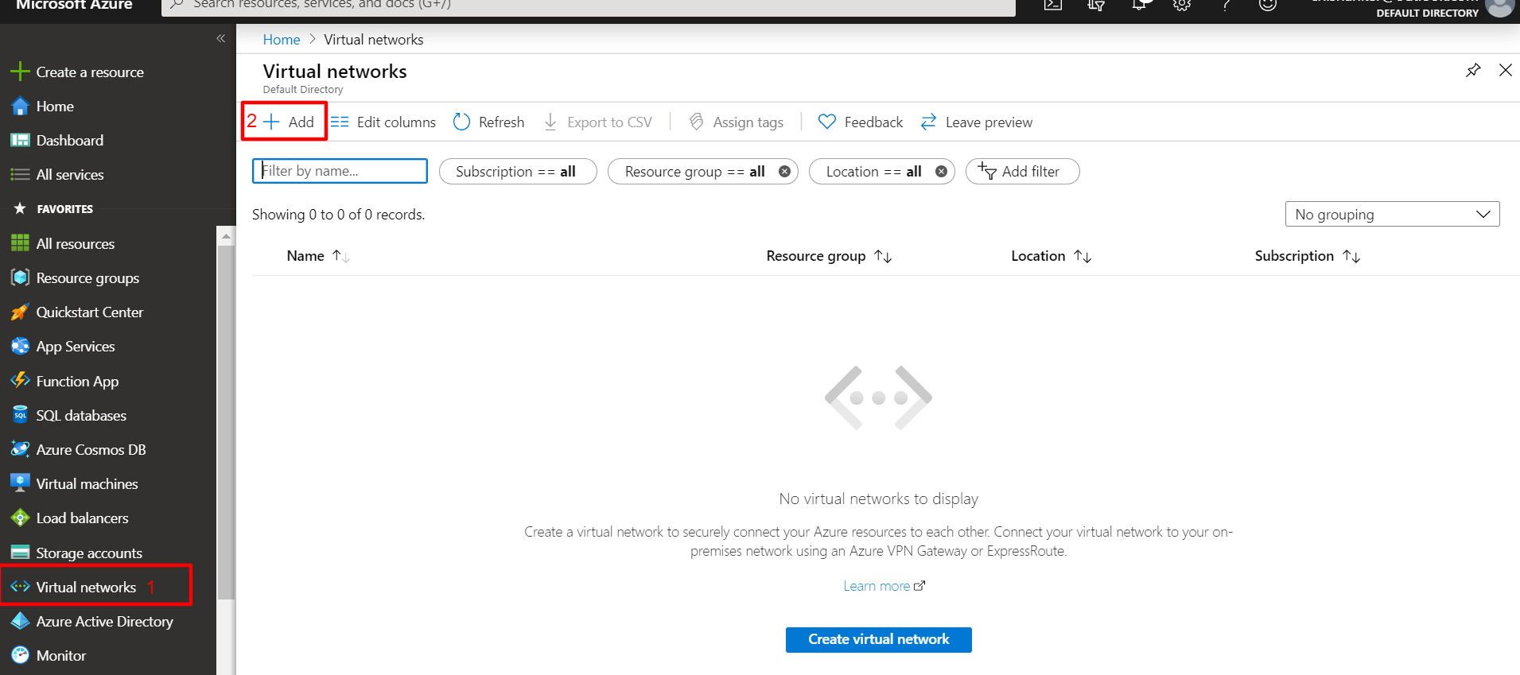

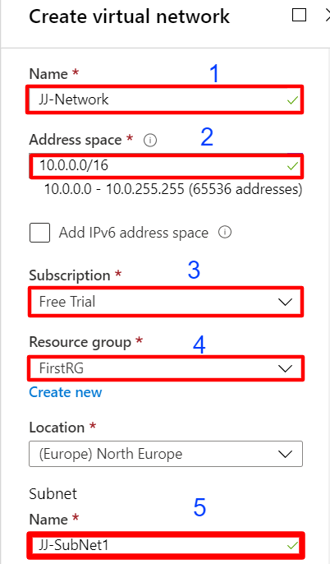

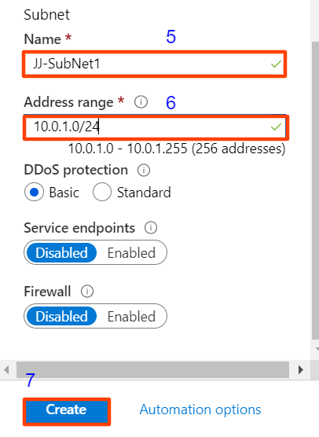

Finally create virtual network

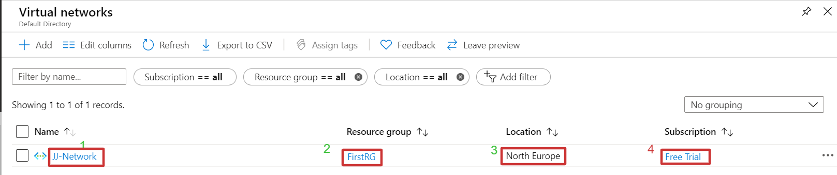

Create second subnet with existing networks

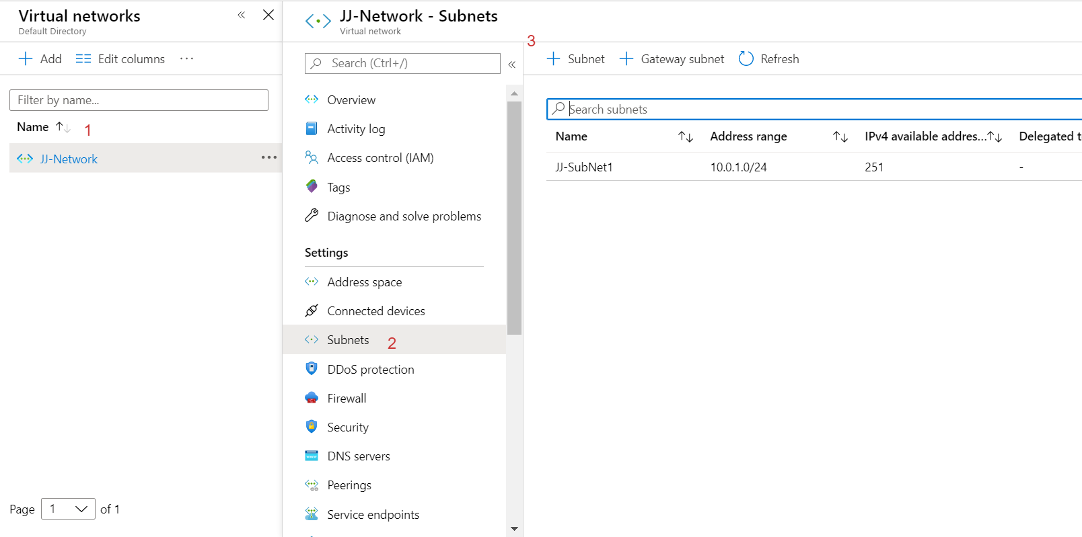

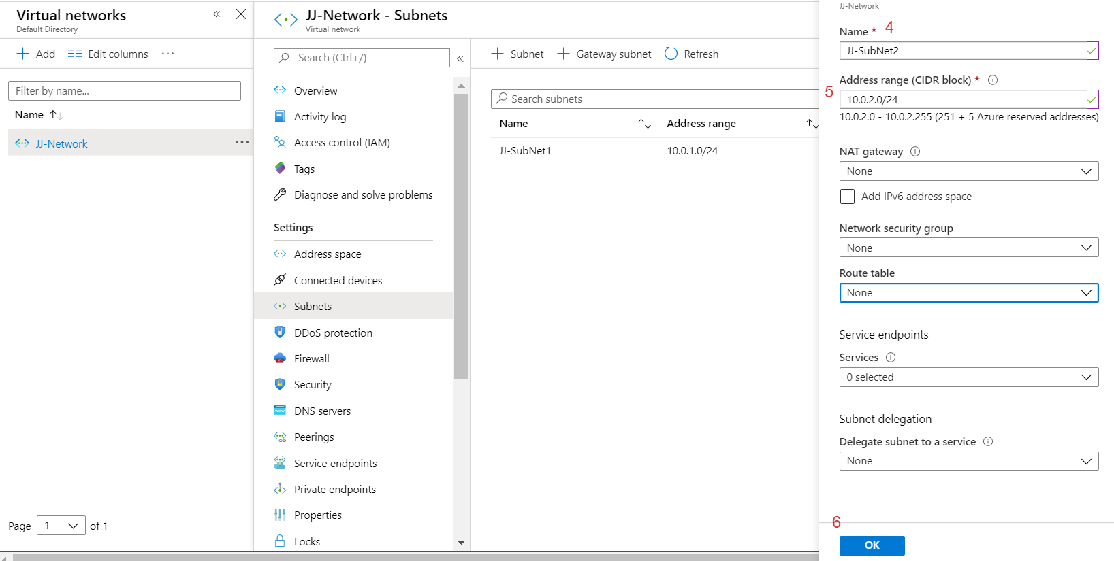

Verify the second subnet creation in existing network group

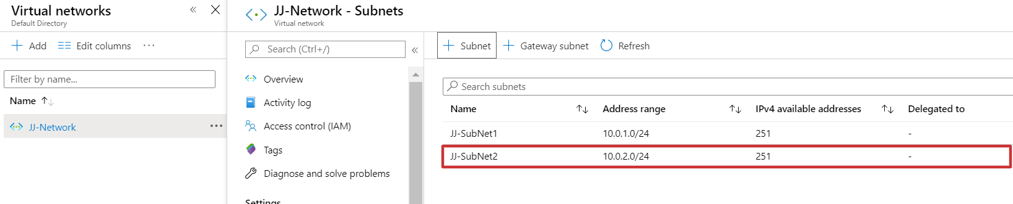

Create virtual machine in existing network

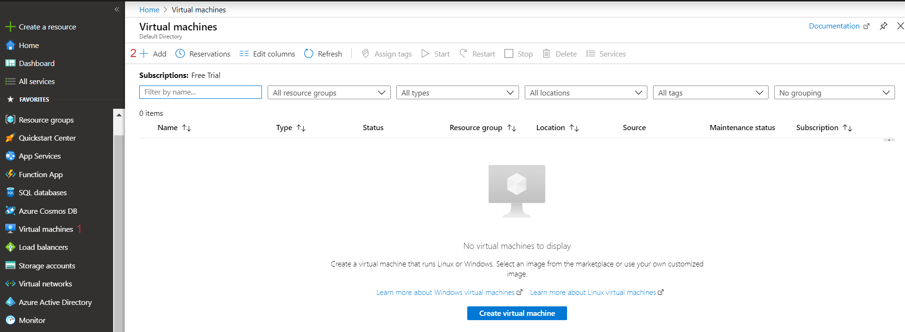

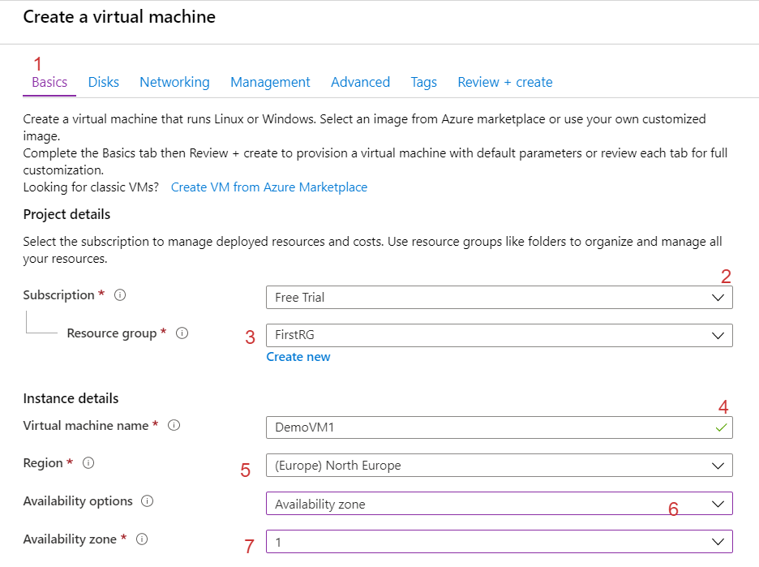

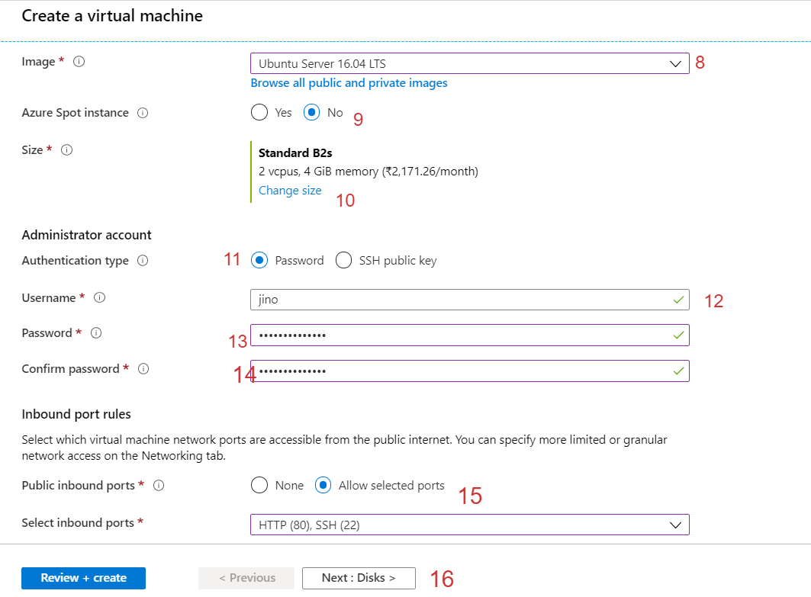

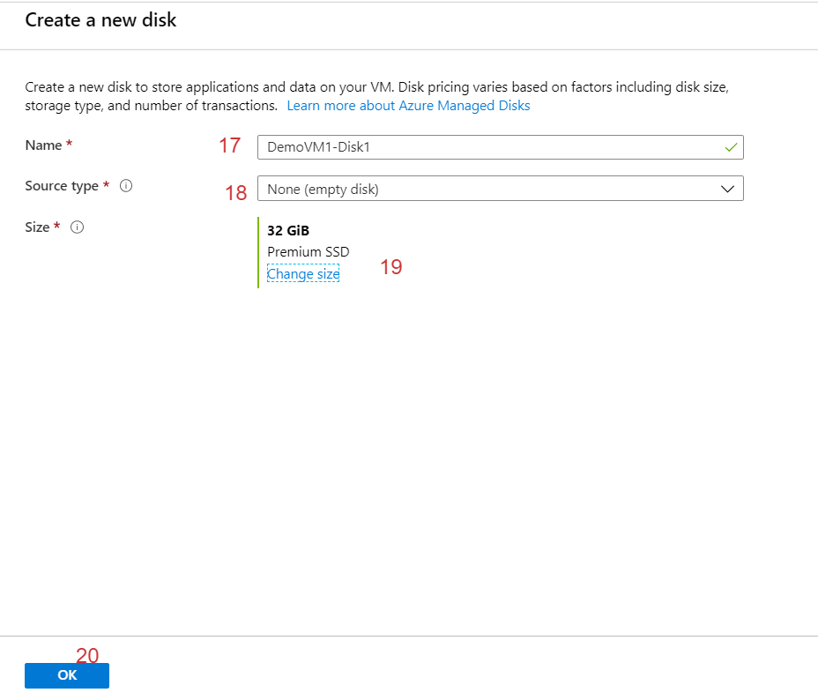

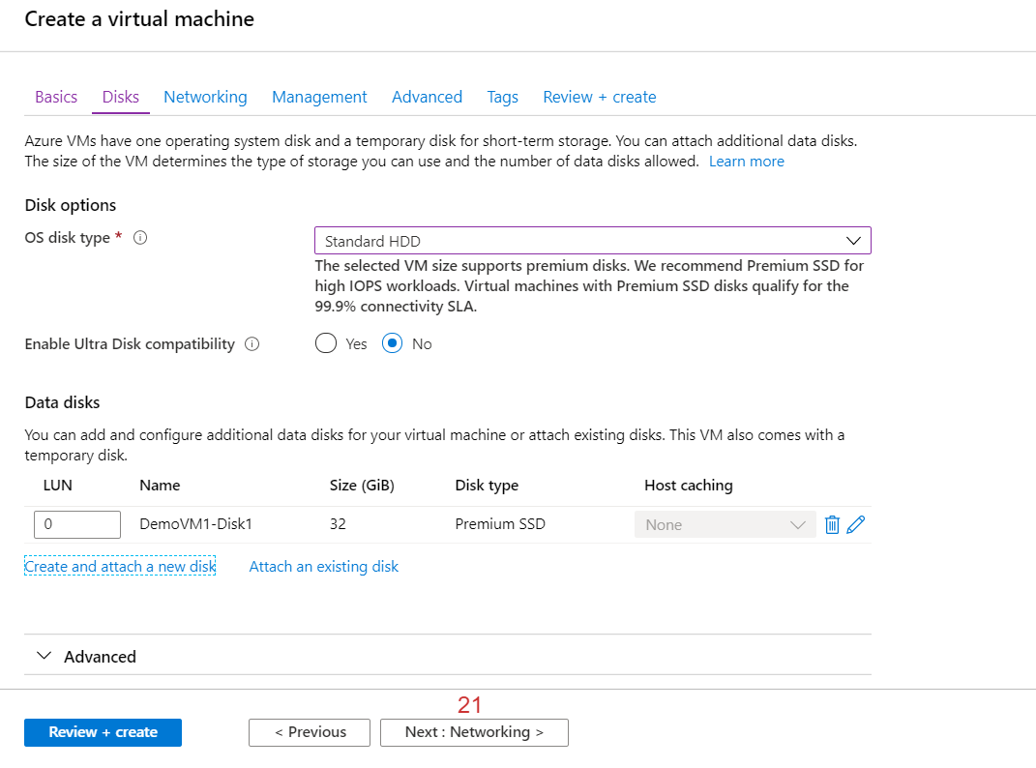

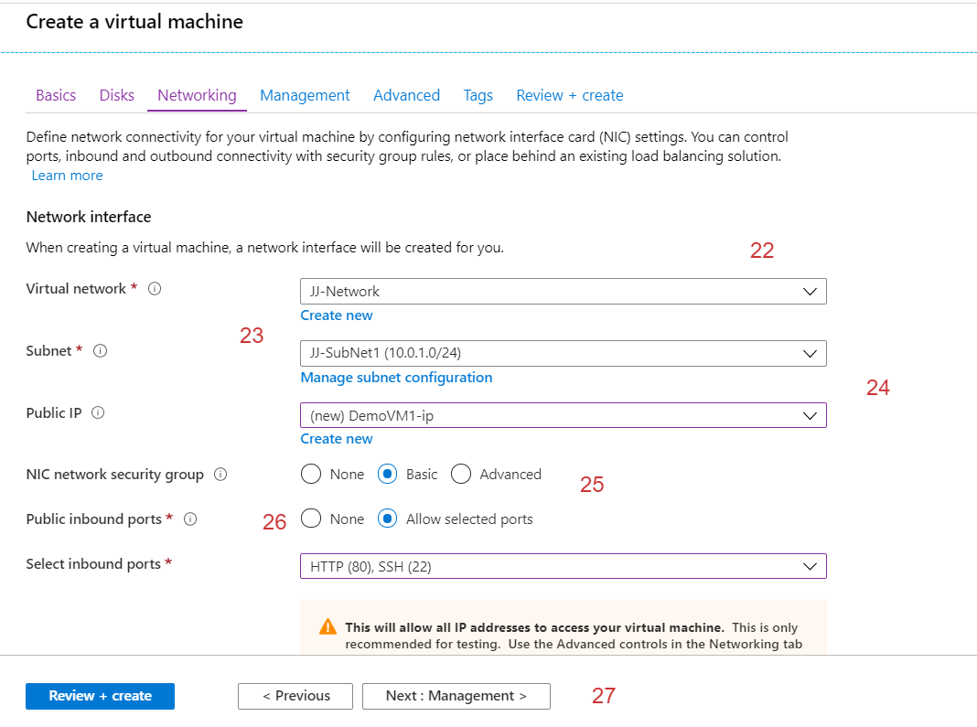

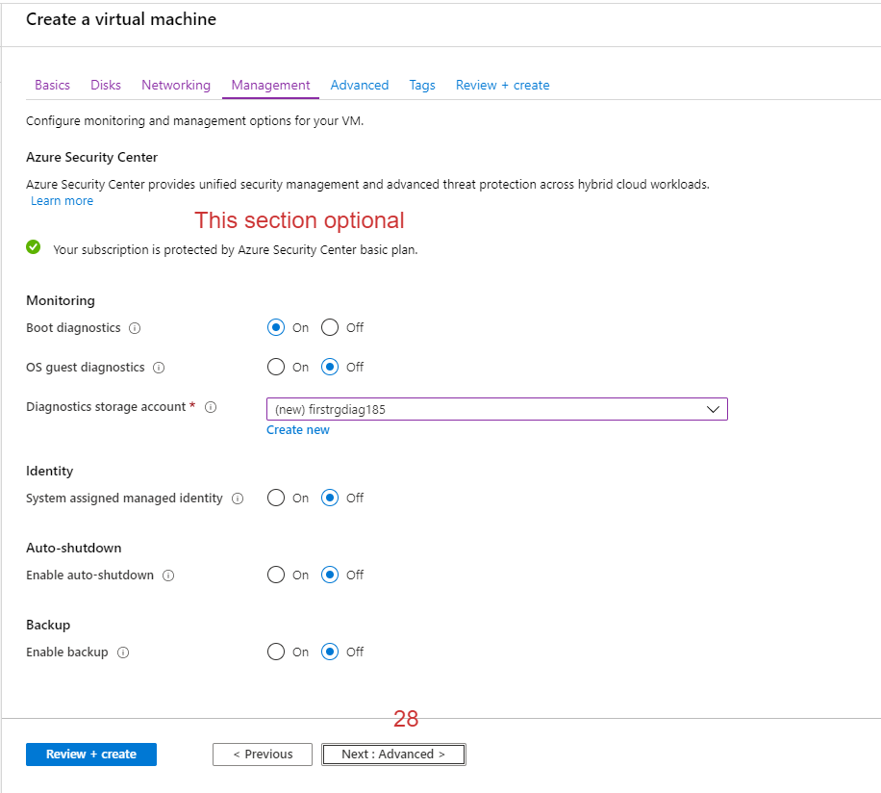

Run time configuration in Azure use cloud-init scripts

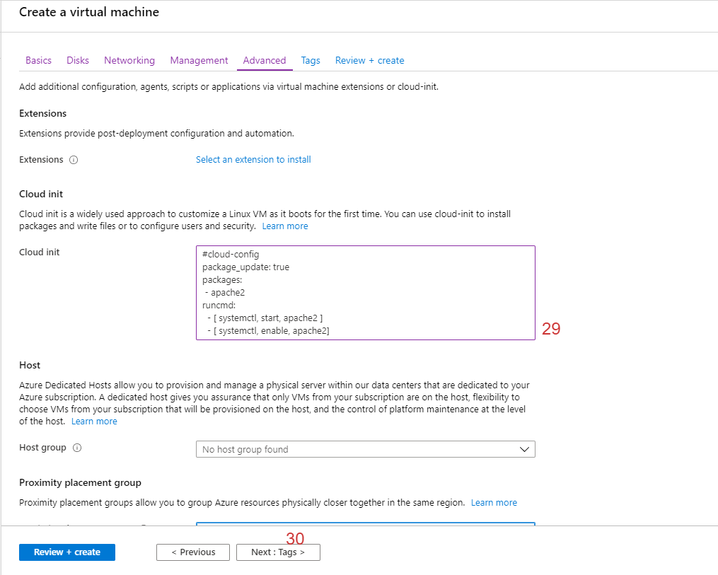

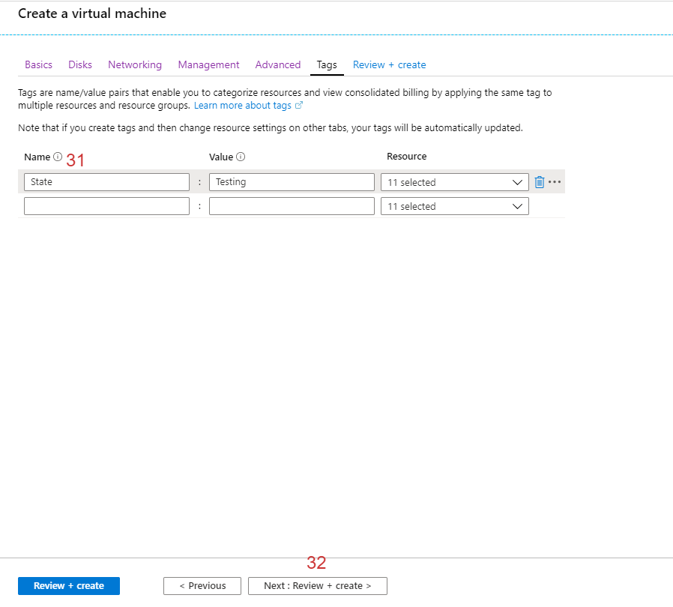

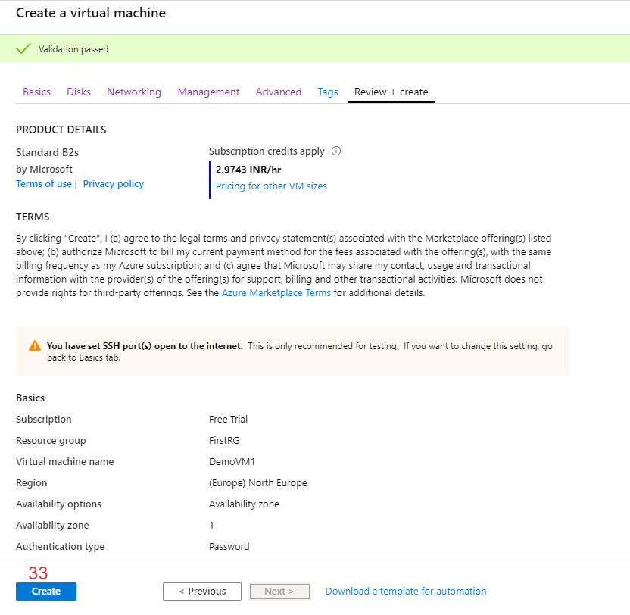

Finally Create VM

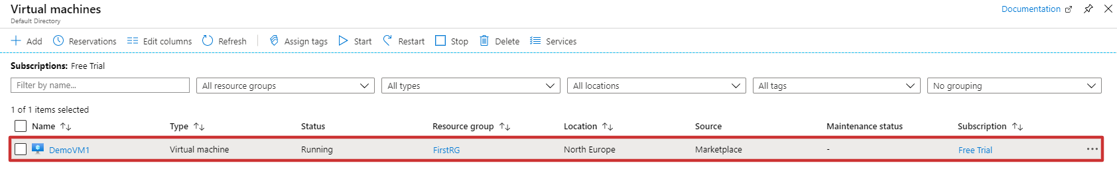

How to connect this vm

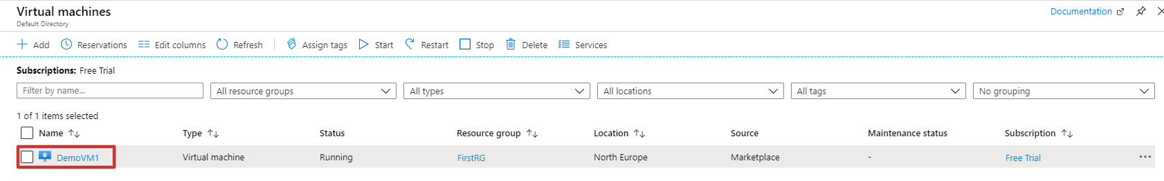

Click it

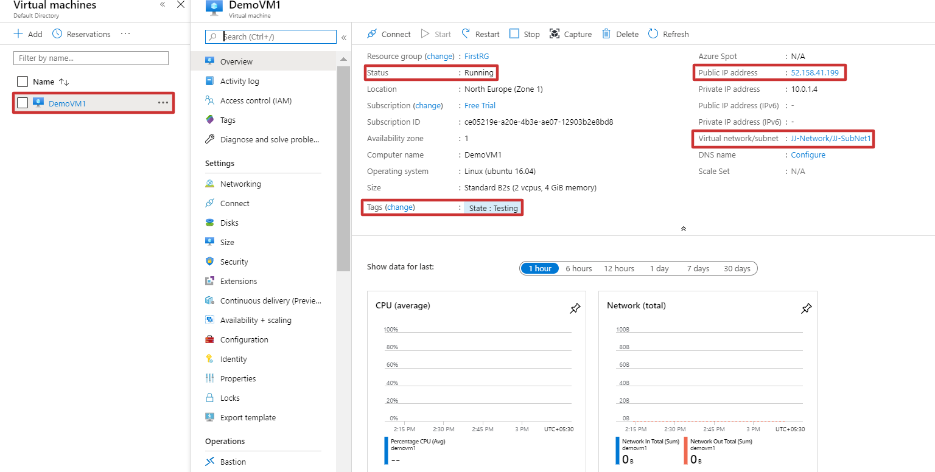

Verify our cloud-init scripts are working.

Open your browser and paste your VM instance IP and check the result

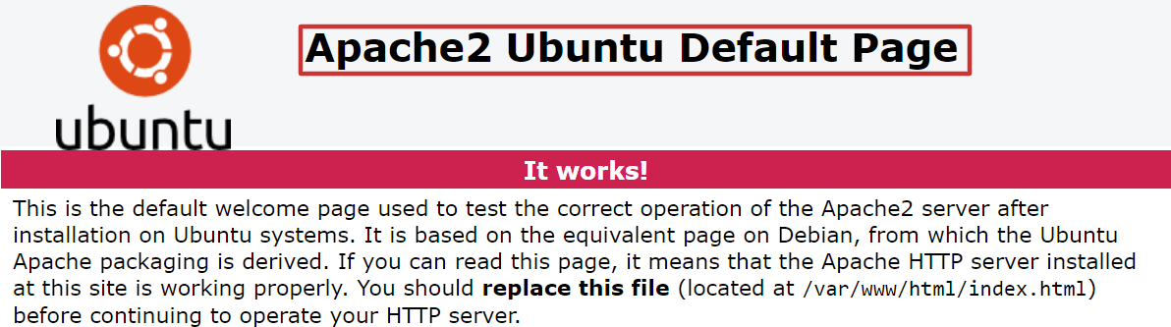

How to connect azure-cli in azure account

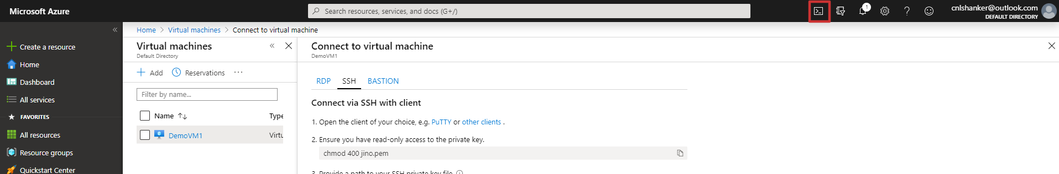

Click it and connect to your instance via ssh

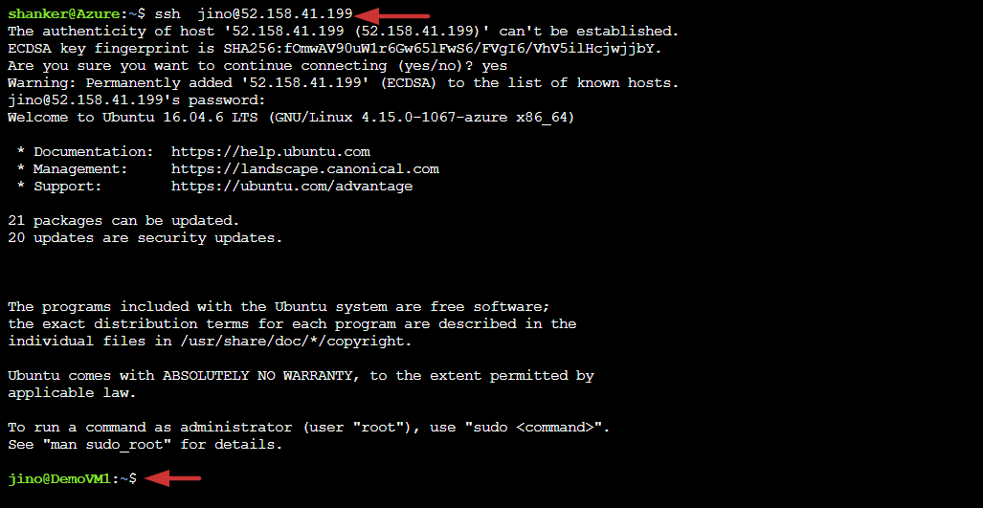

External disk mount to virtual machine

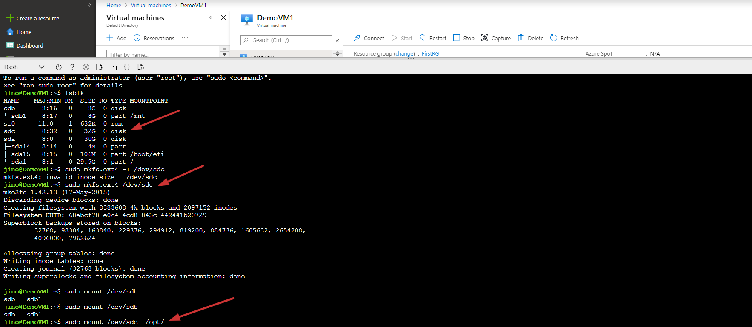

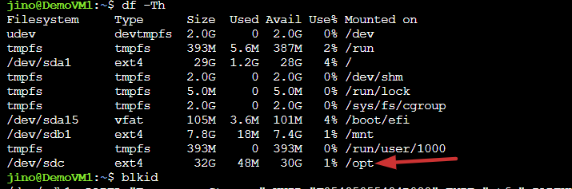

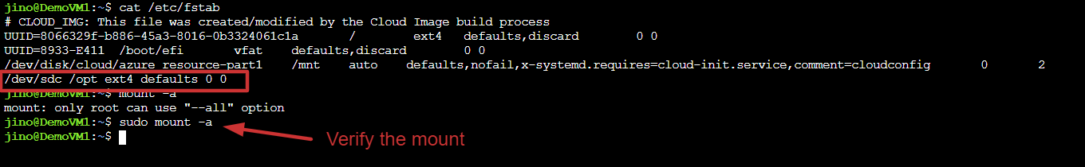

**Load balancer configuration in azure**

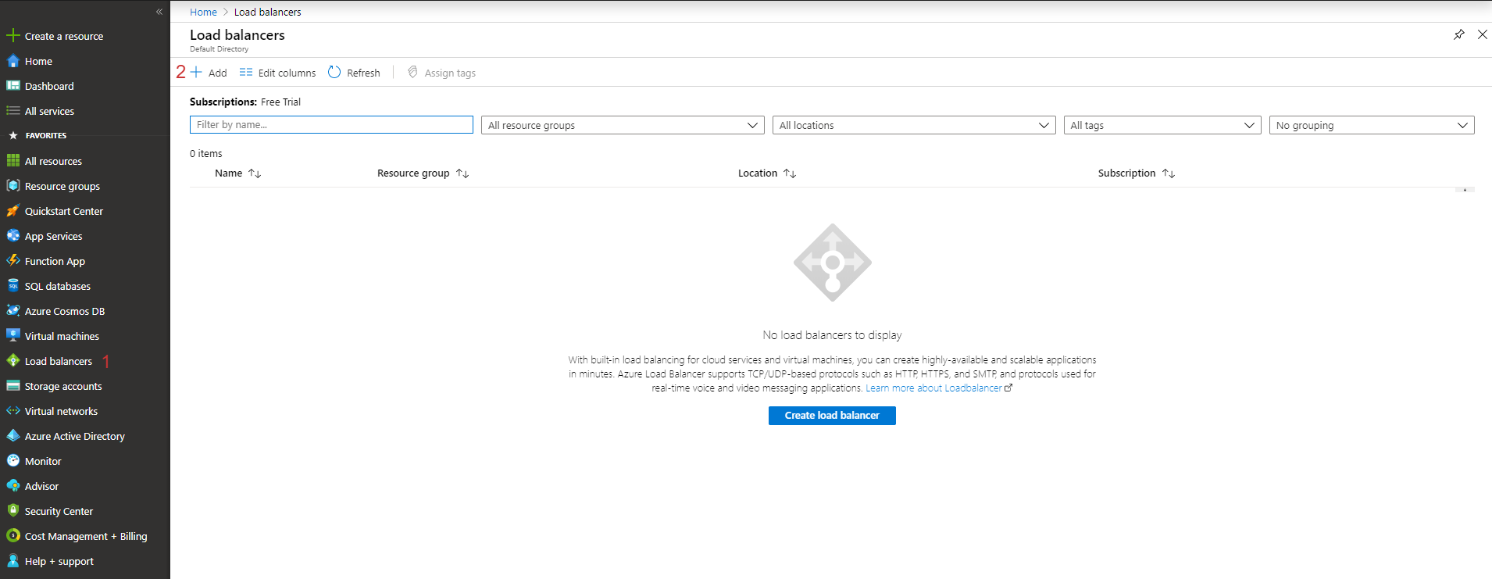

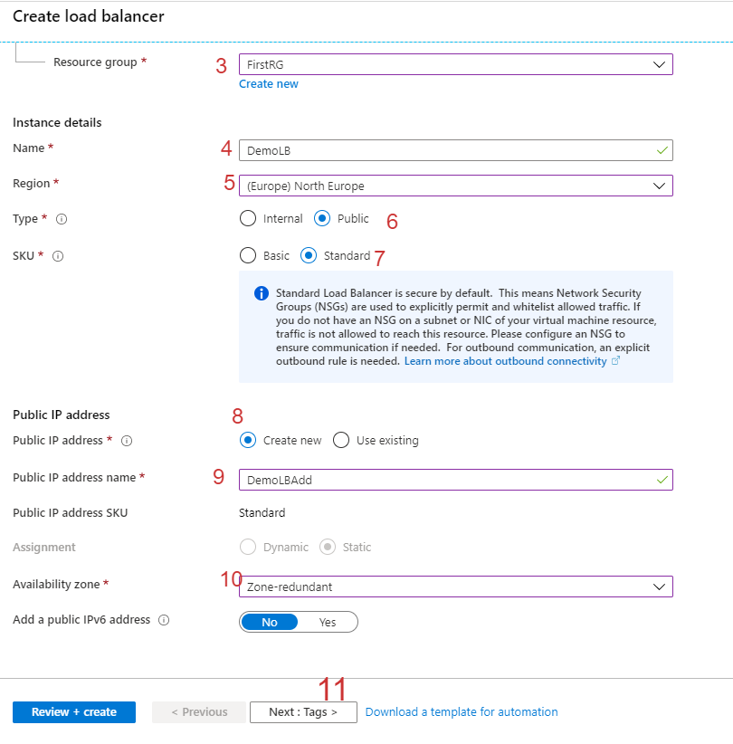

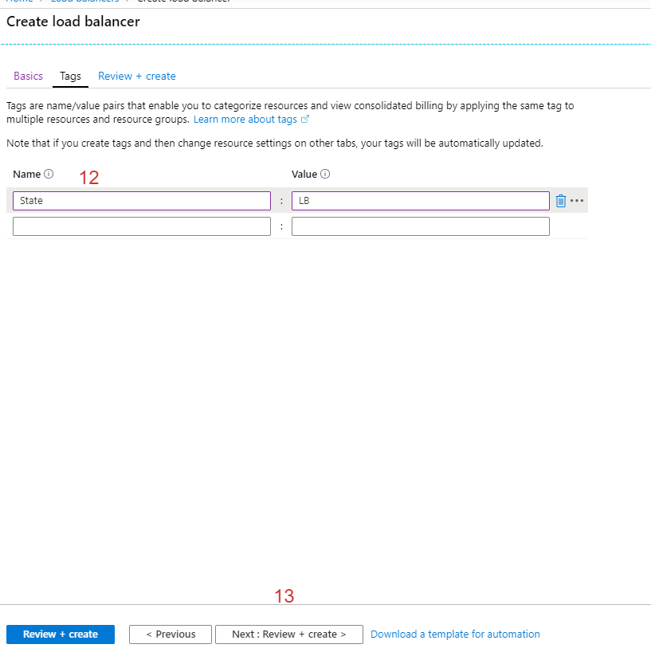

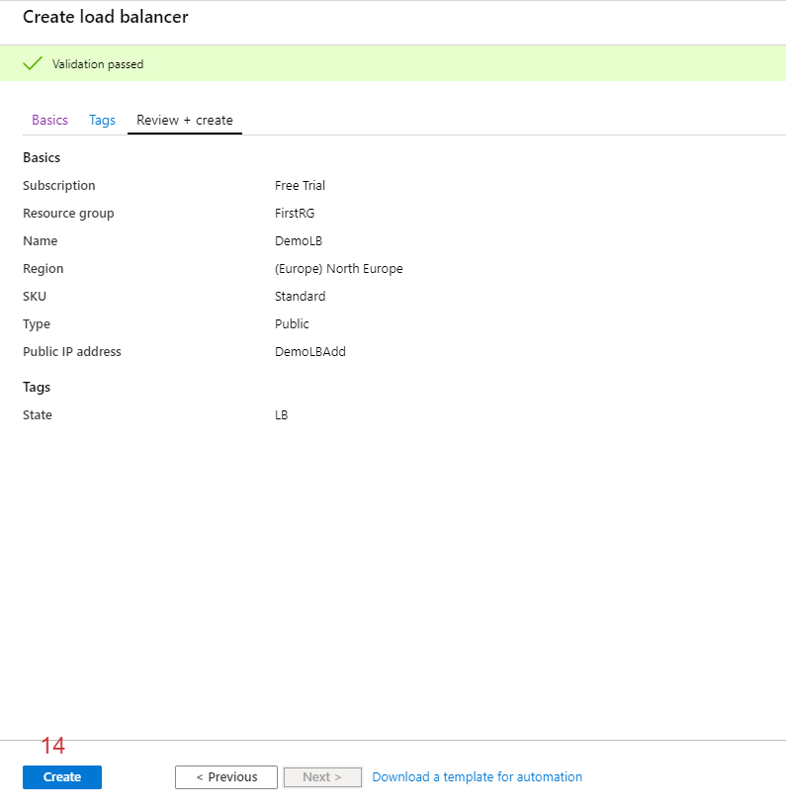

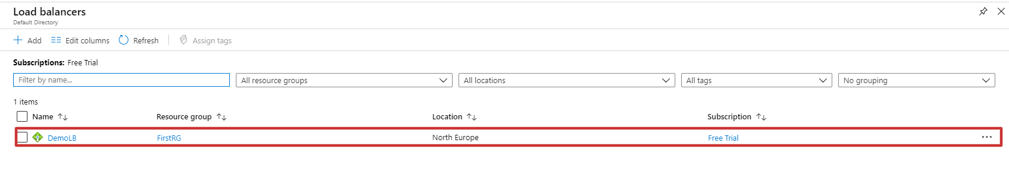

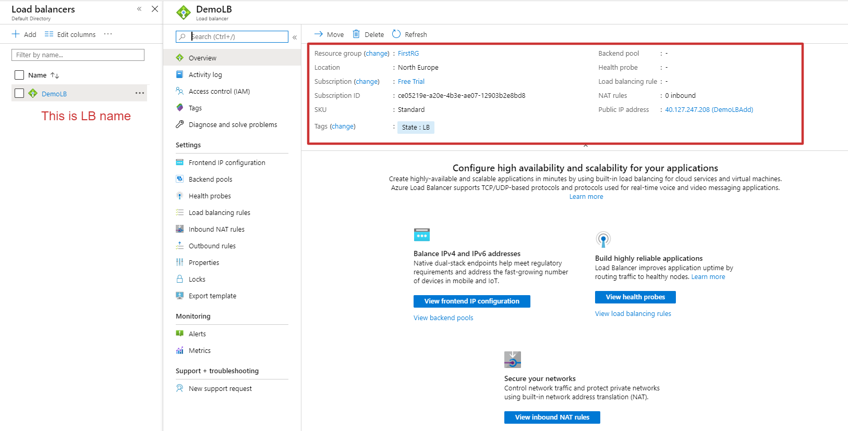

Existing virtual machine connect to LB

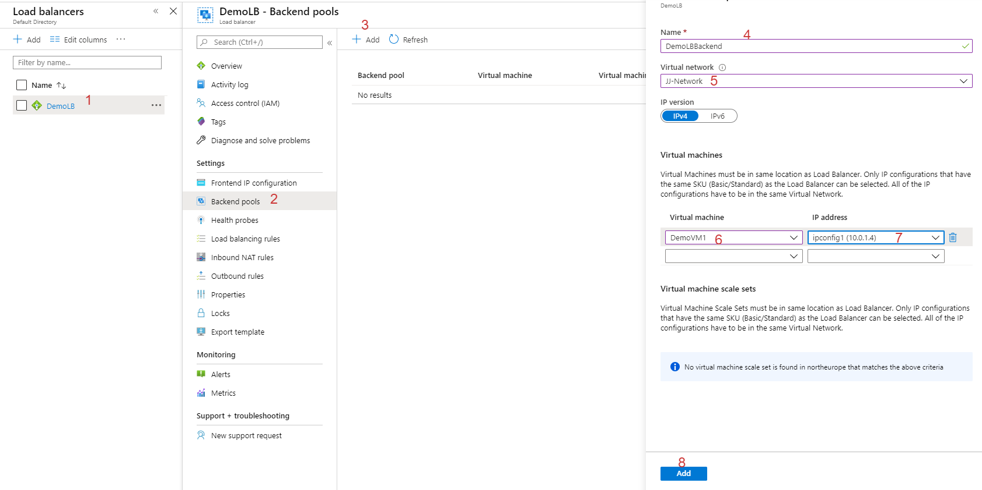

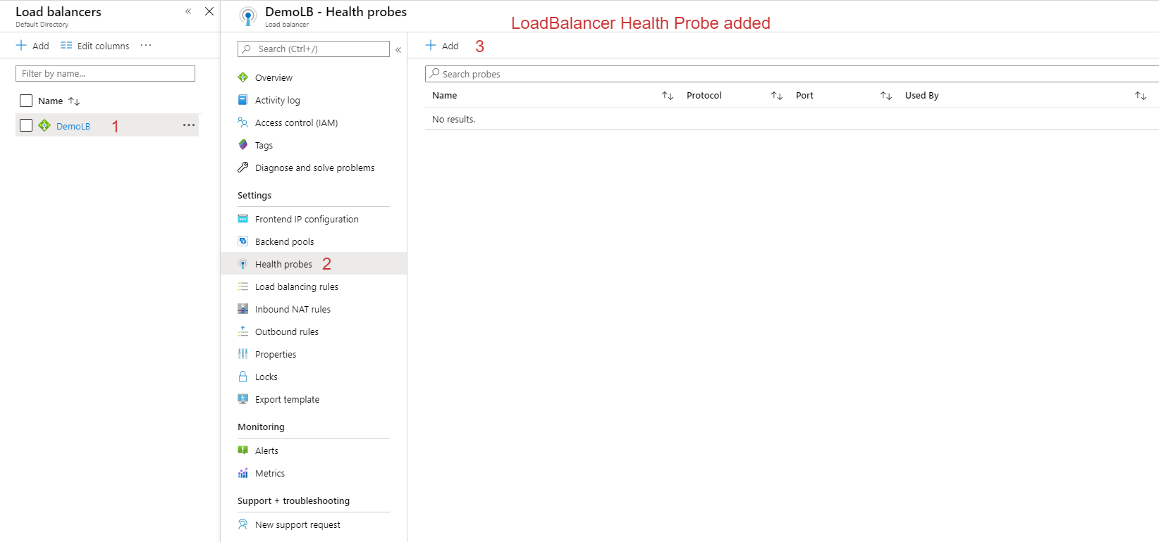

Now able to reach your virtual machine (http) via load balancer IP

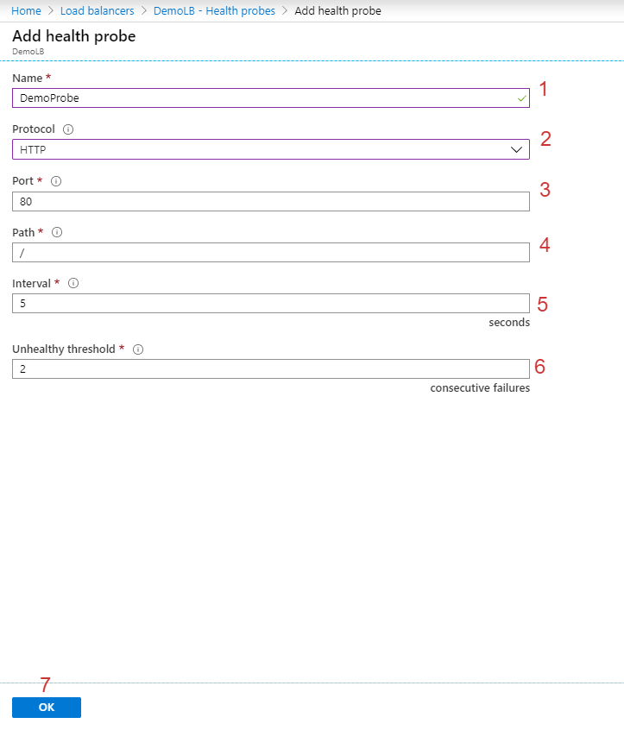

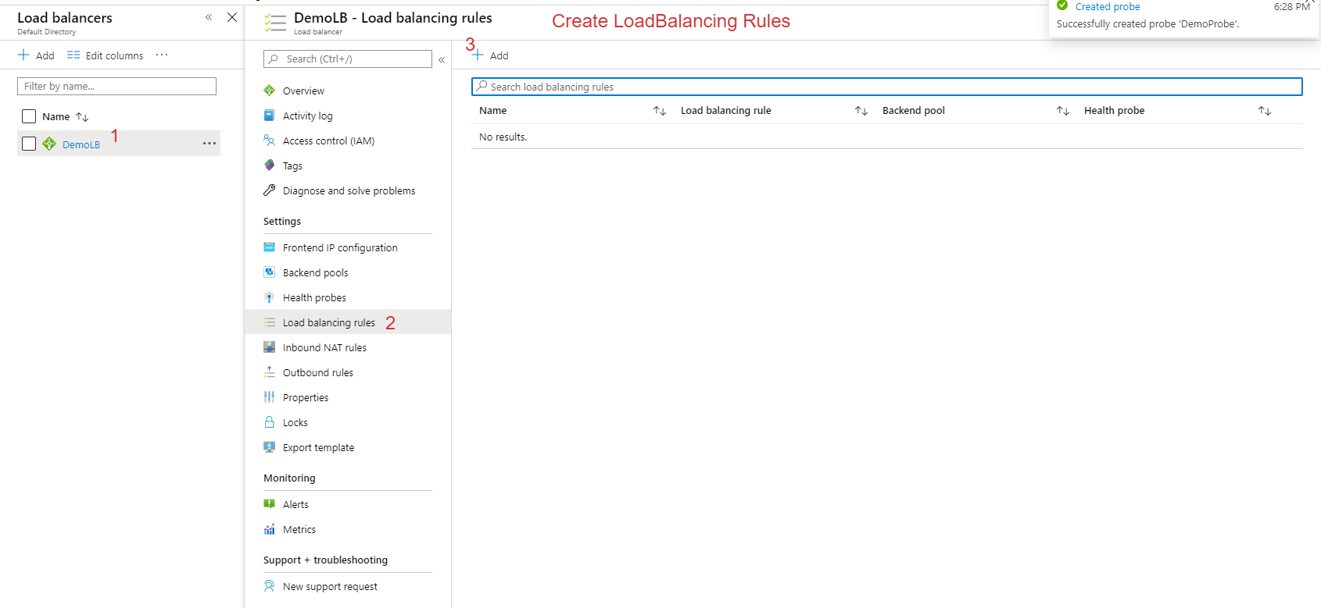

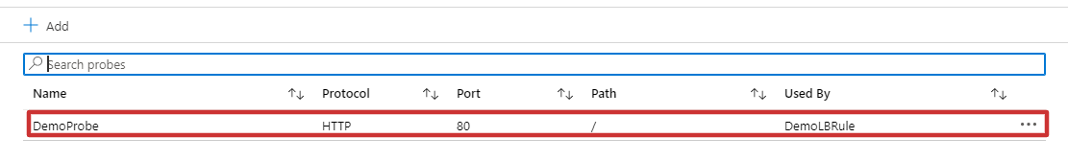

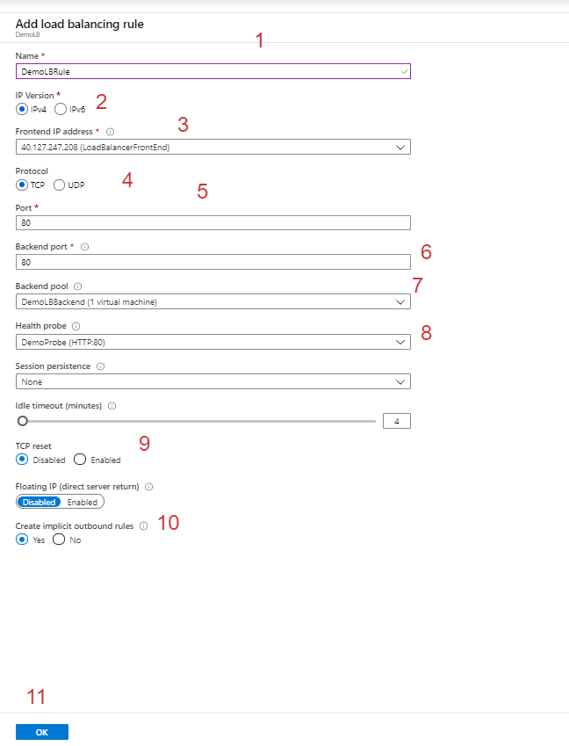

This load balancer rules

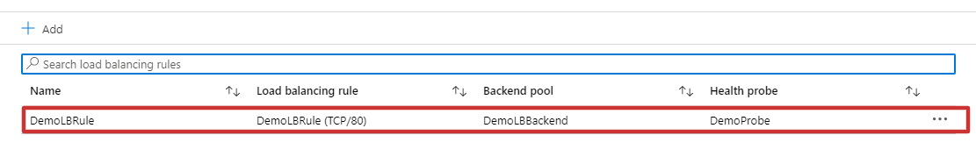

Configure private DNS

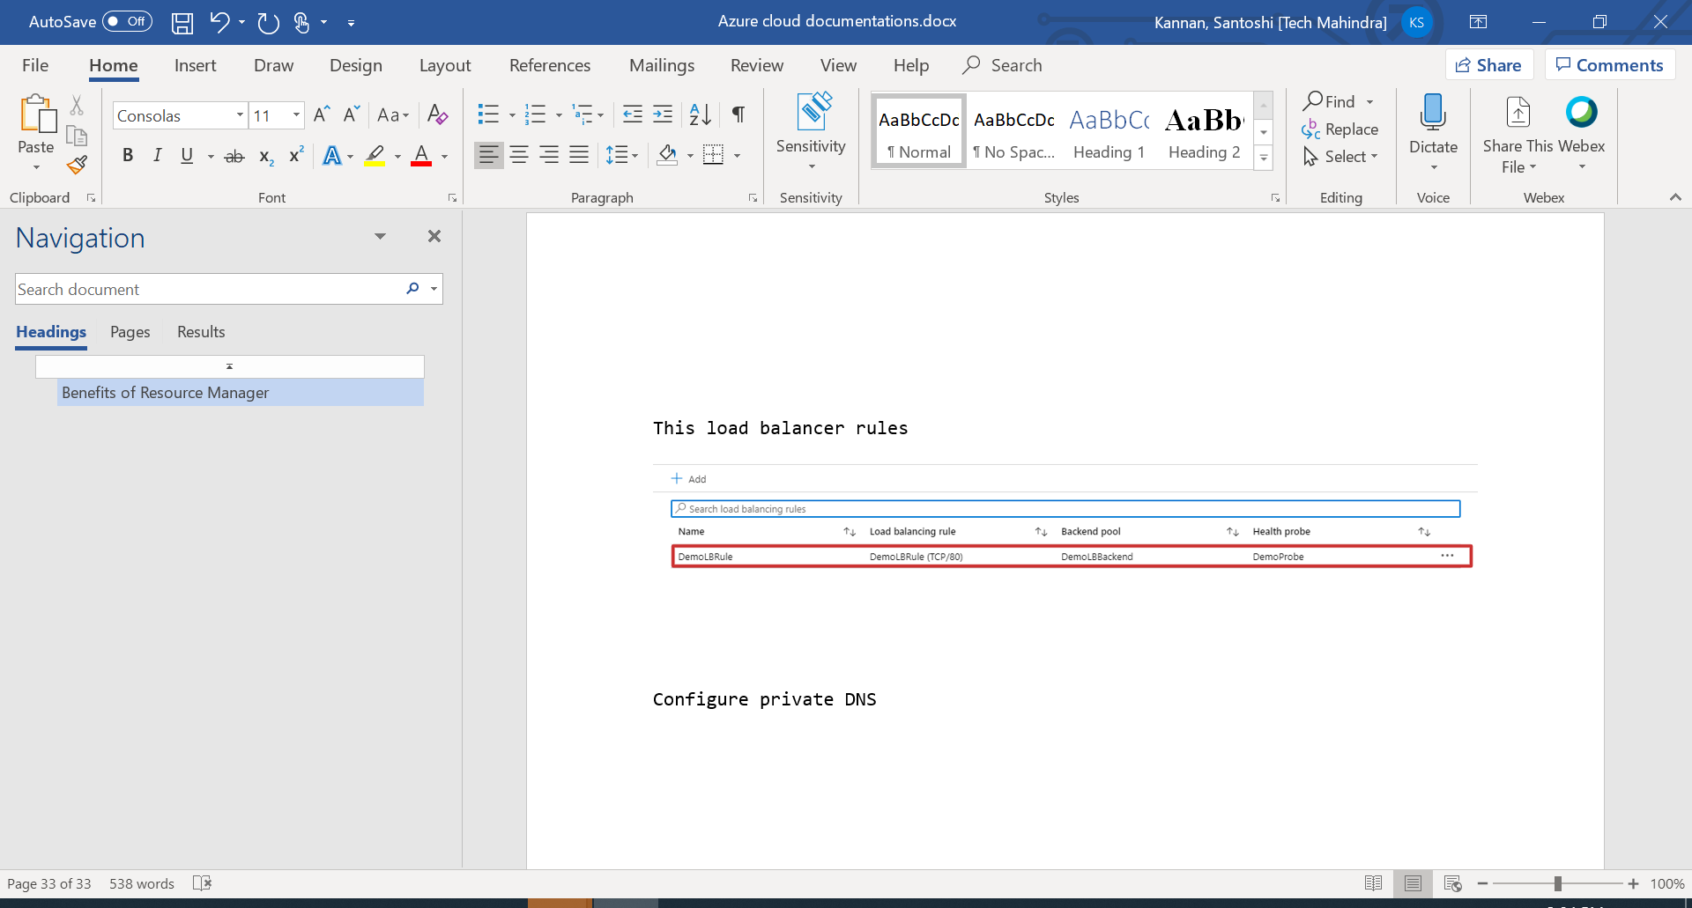

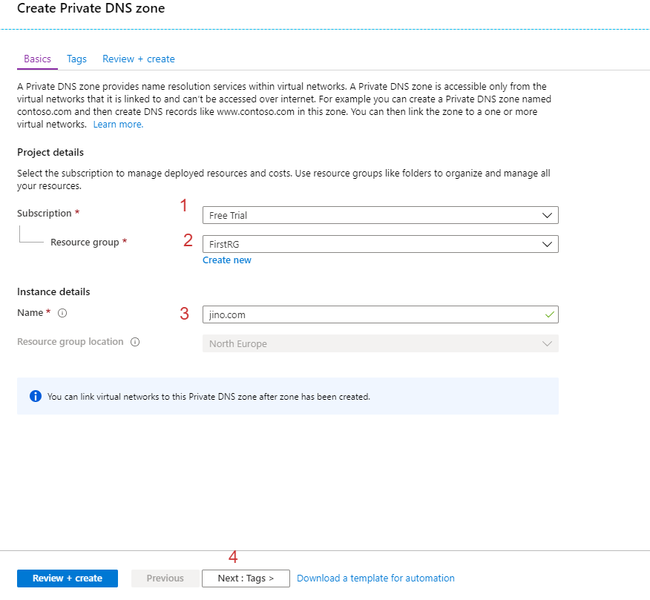

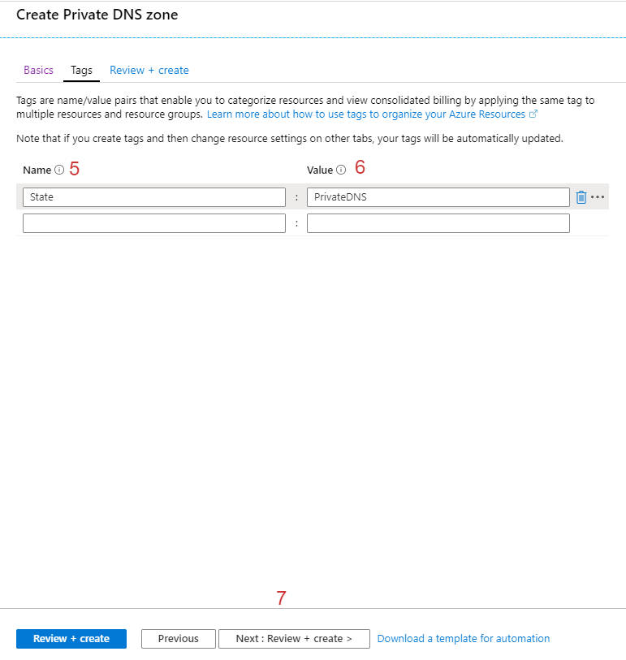

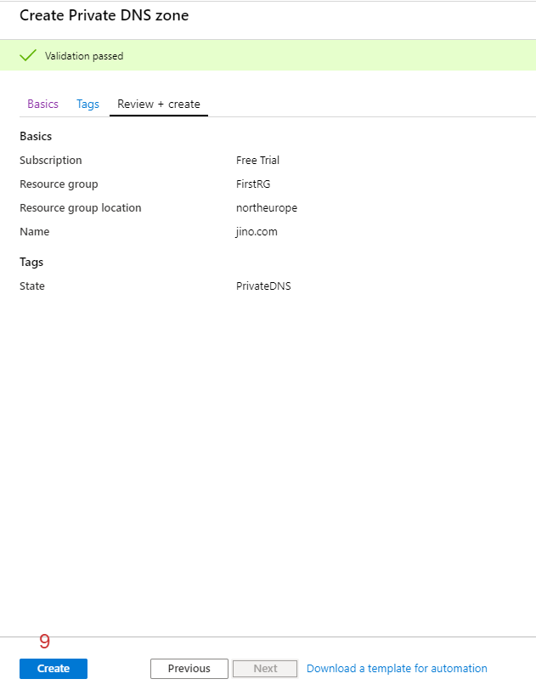

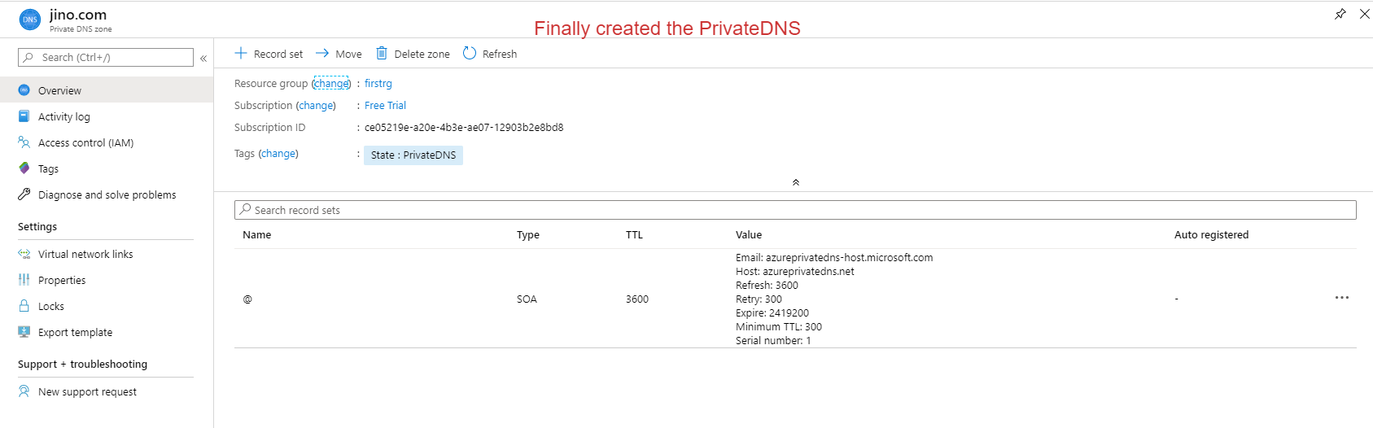

Make DNS entry in Private DNS zone

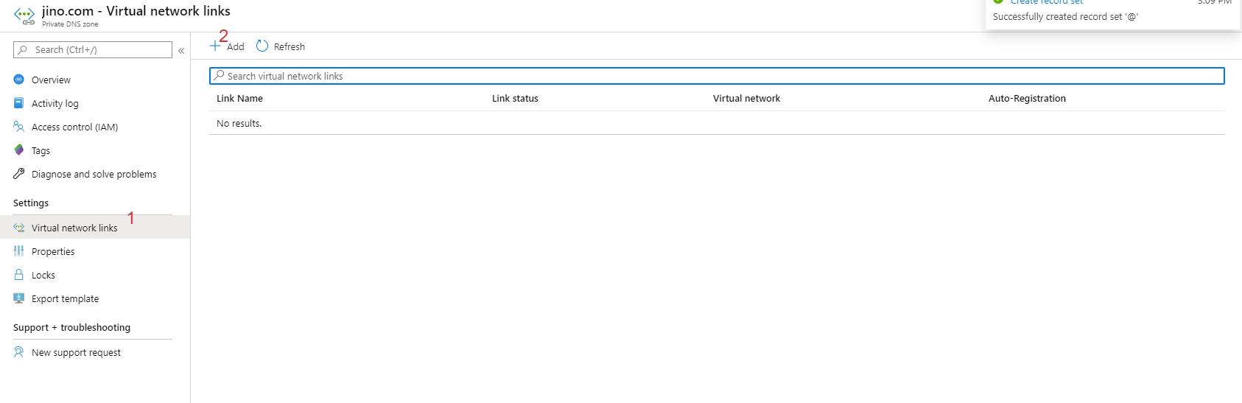

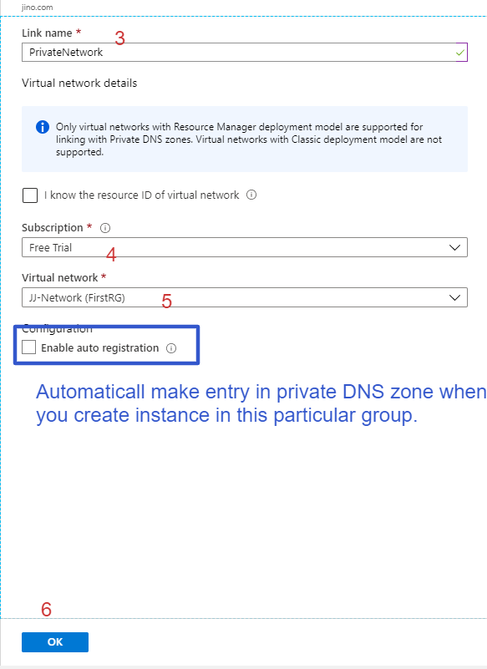

How to create Private DNS name in manually

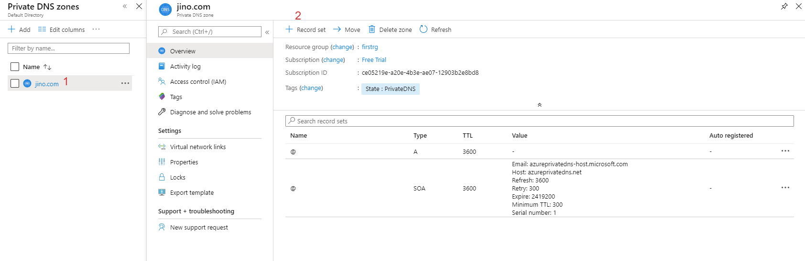

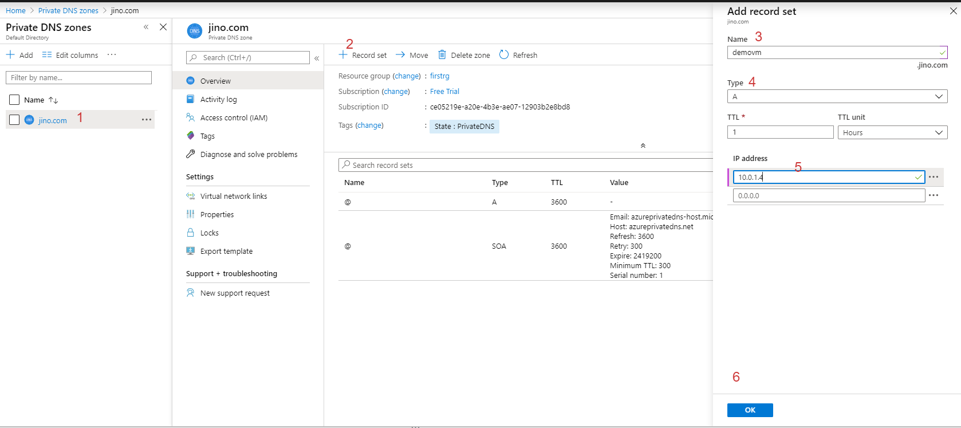

Finally Created

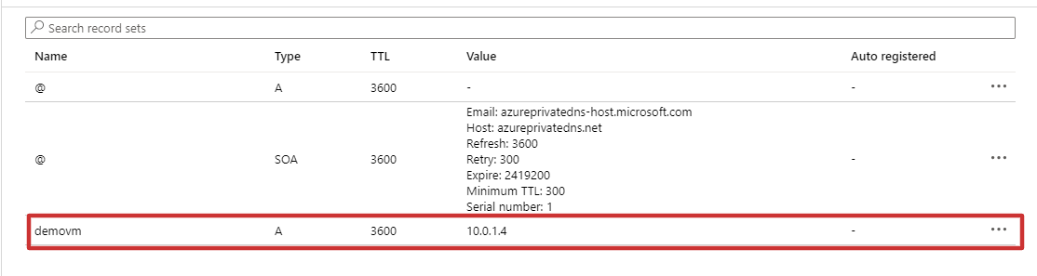

How to check private DNS working methodology

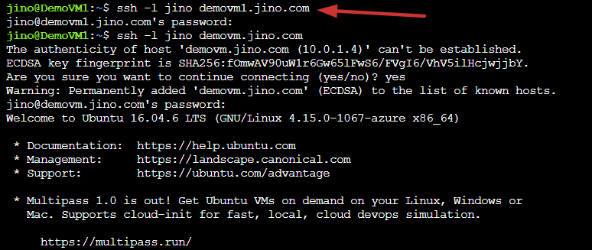

Vnet peering from two networks

Requirements:

1. Two vnets in same resource group in this scenario

App service

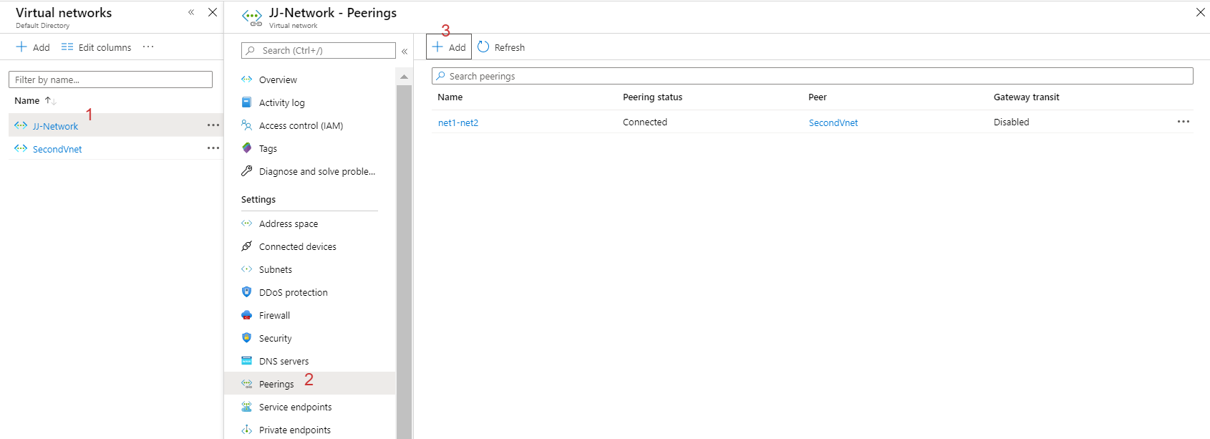

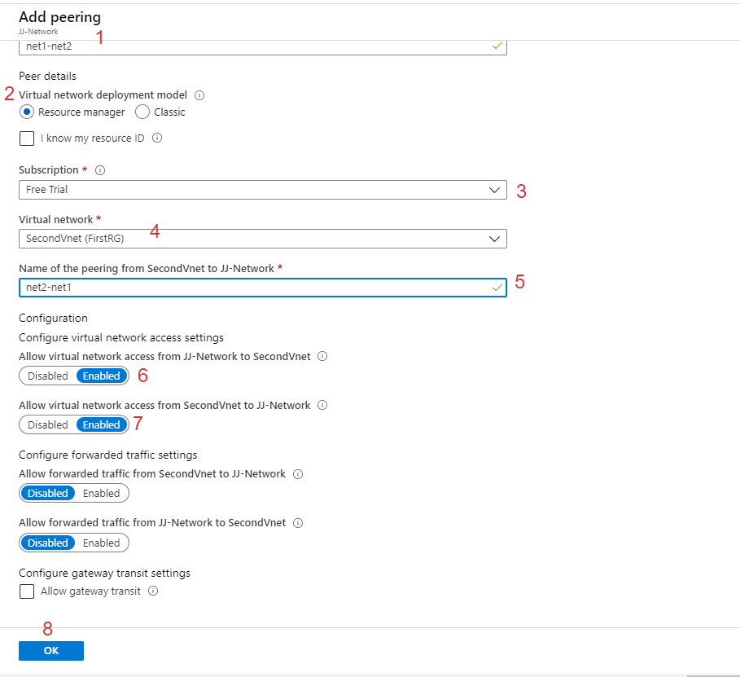

Create Done

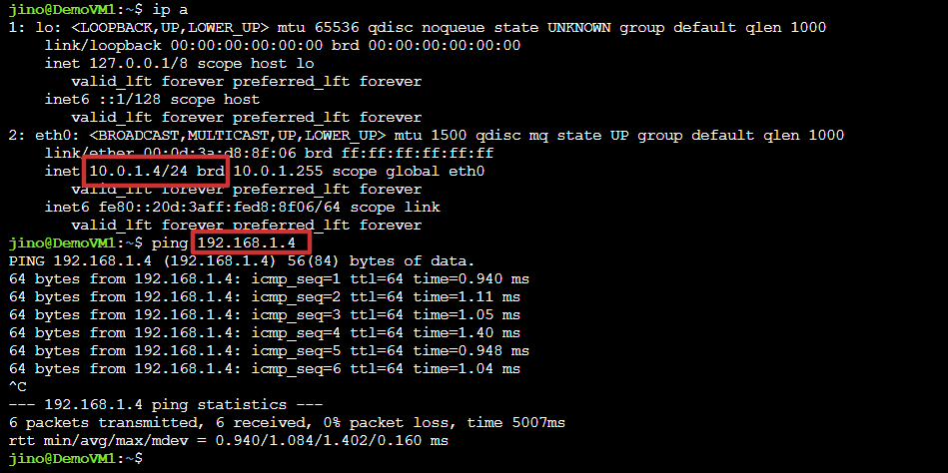

Verify methods once connect & disconnect two virtual networks.

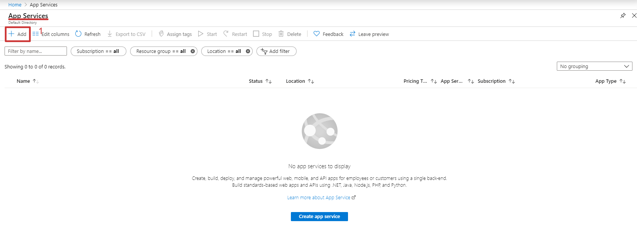

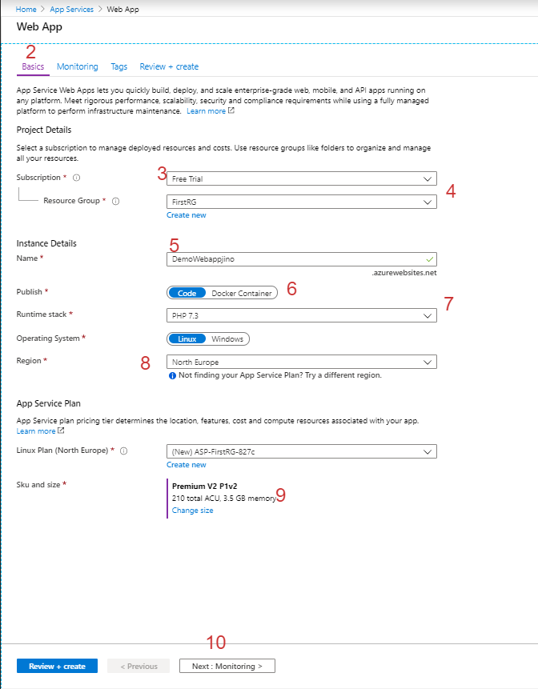

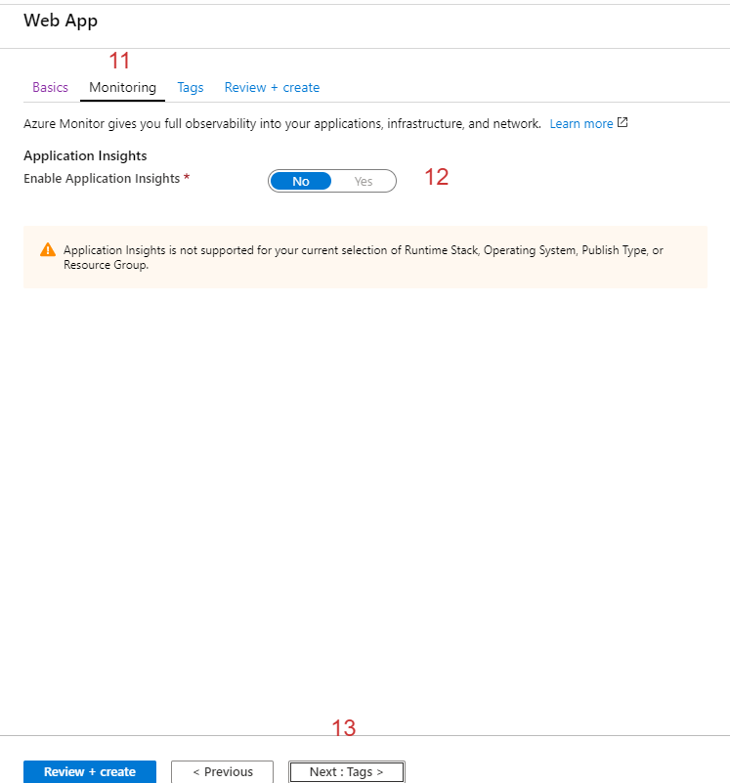

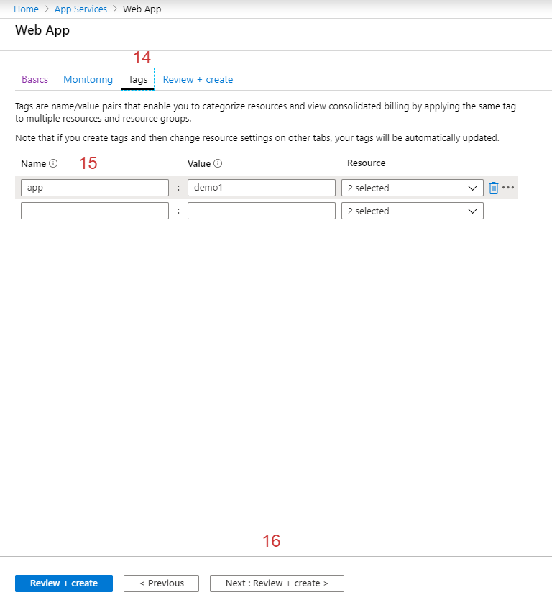

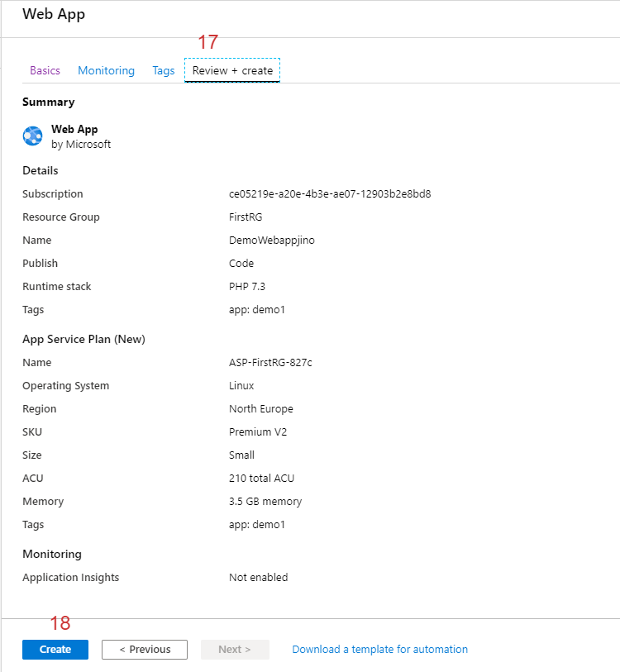

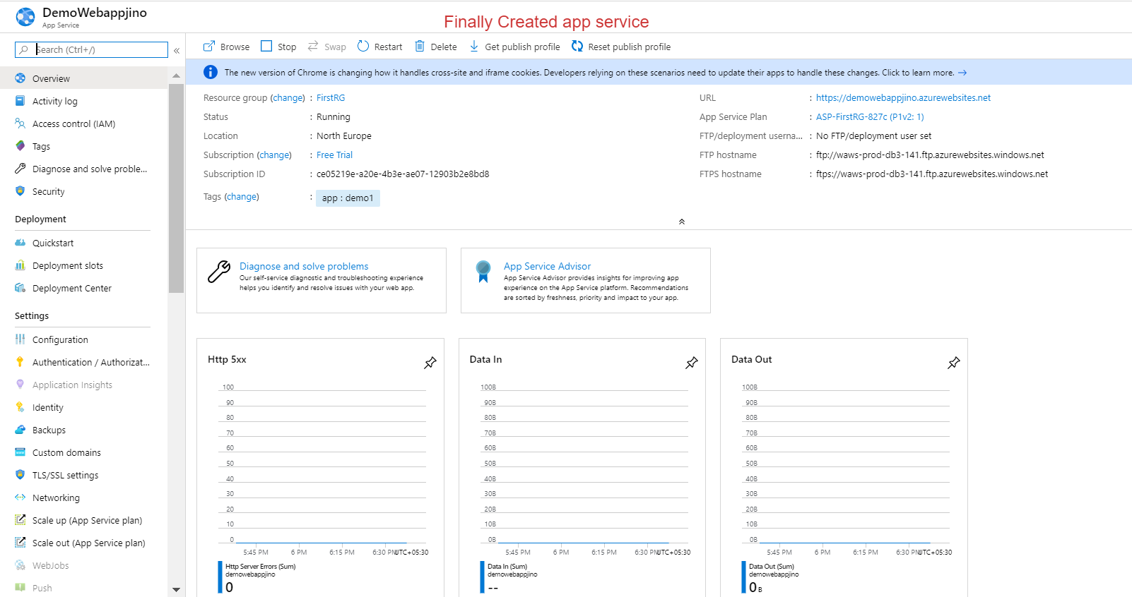

Application deploy via

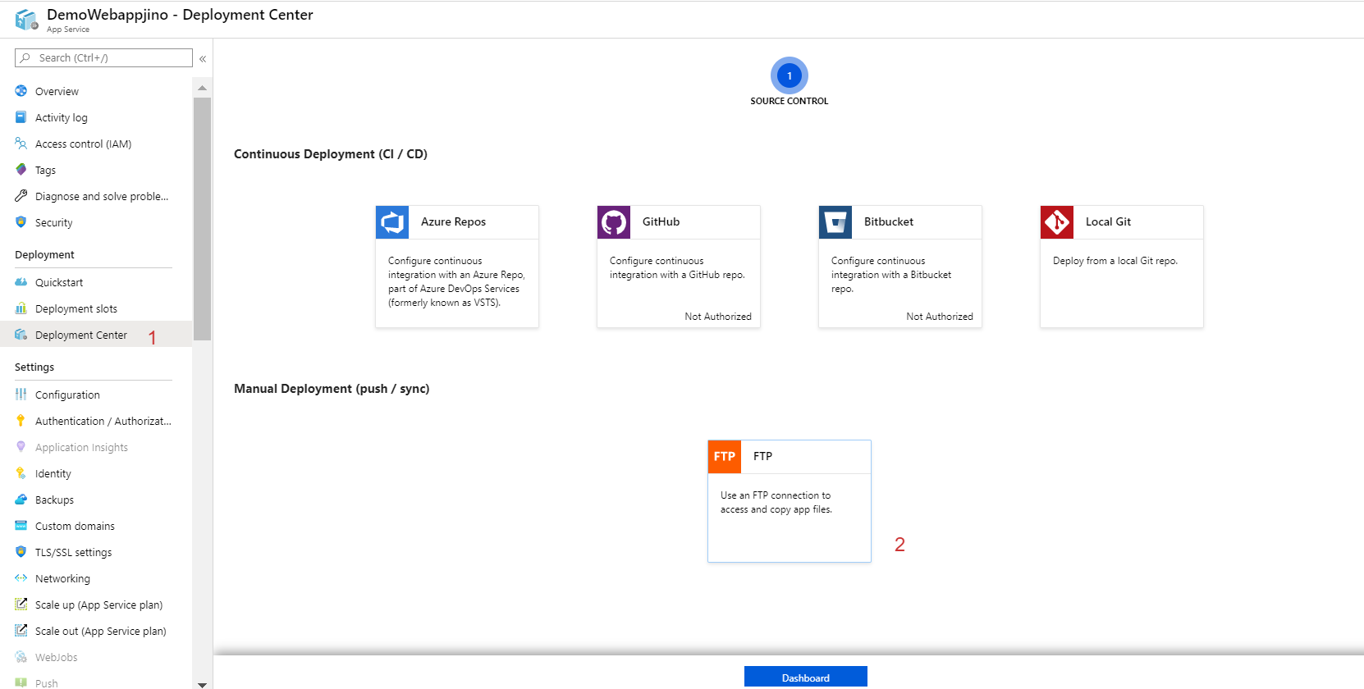

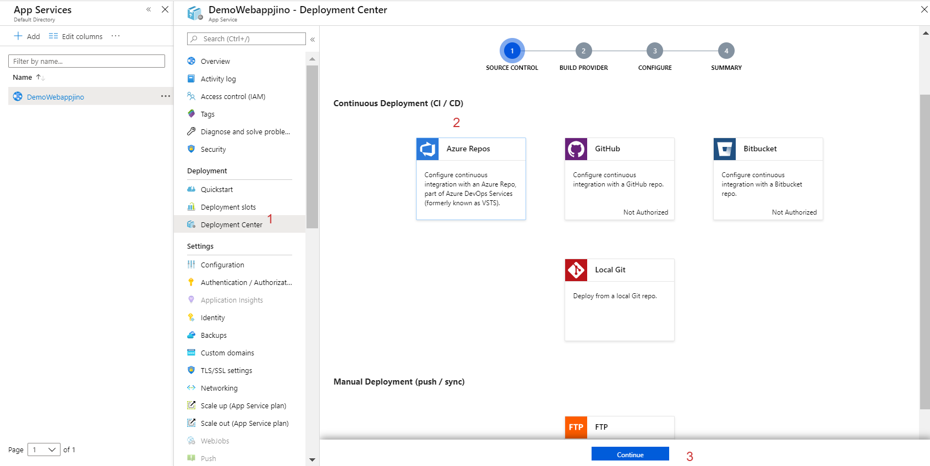

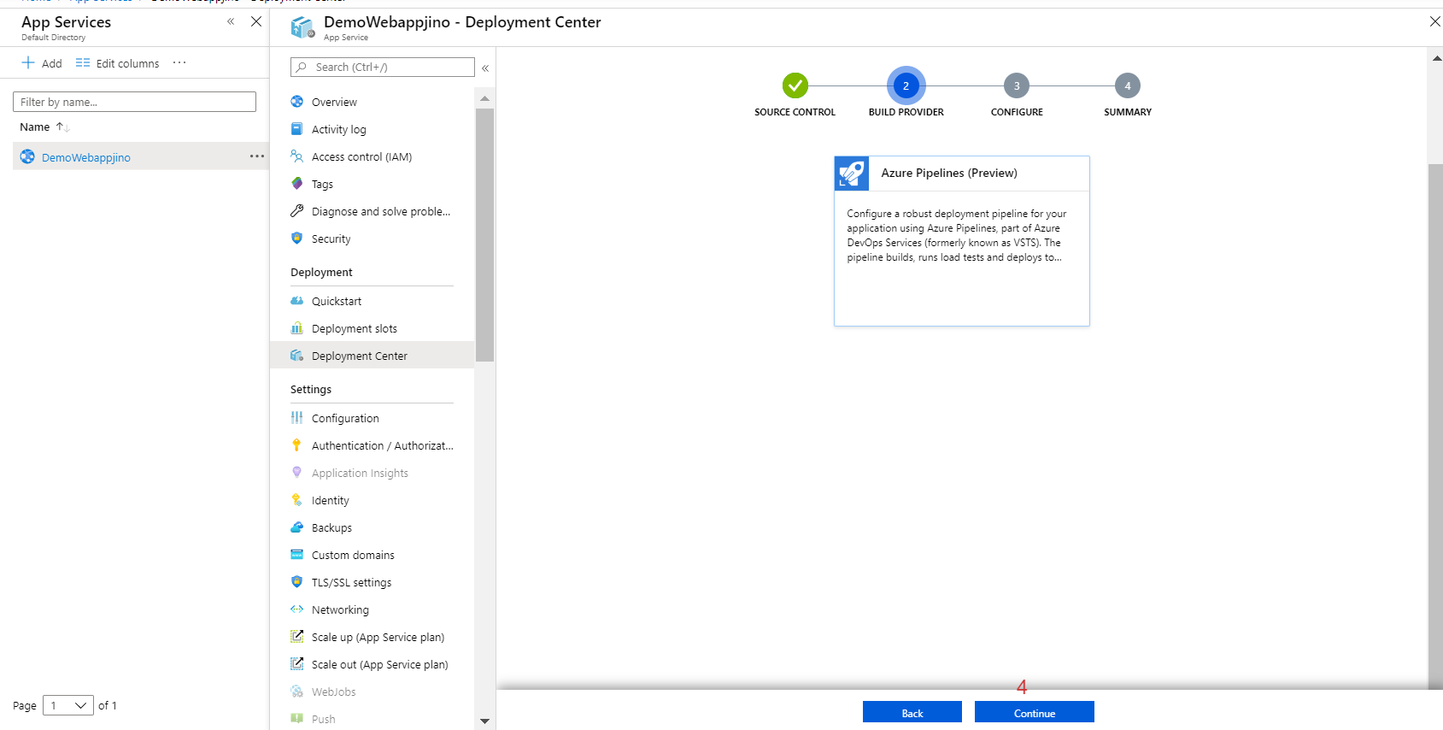

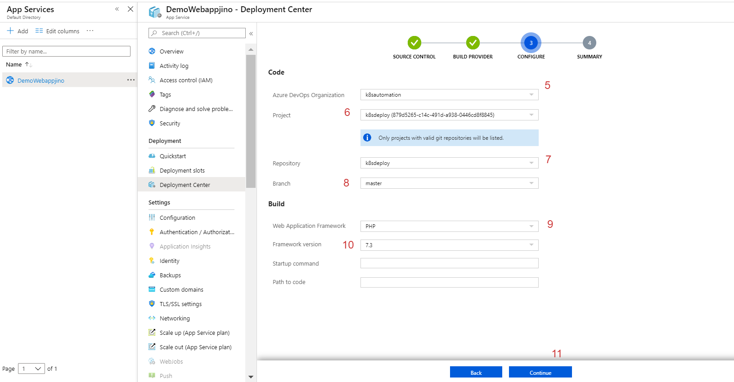

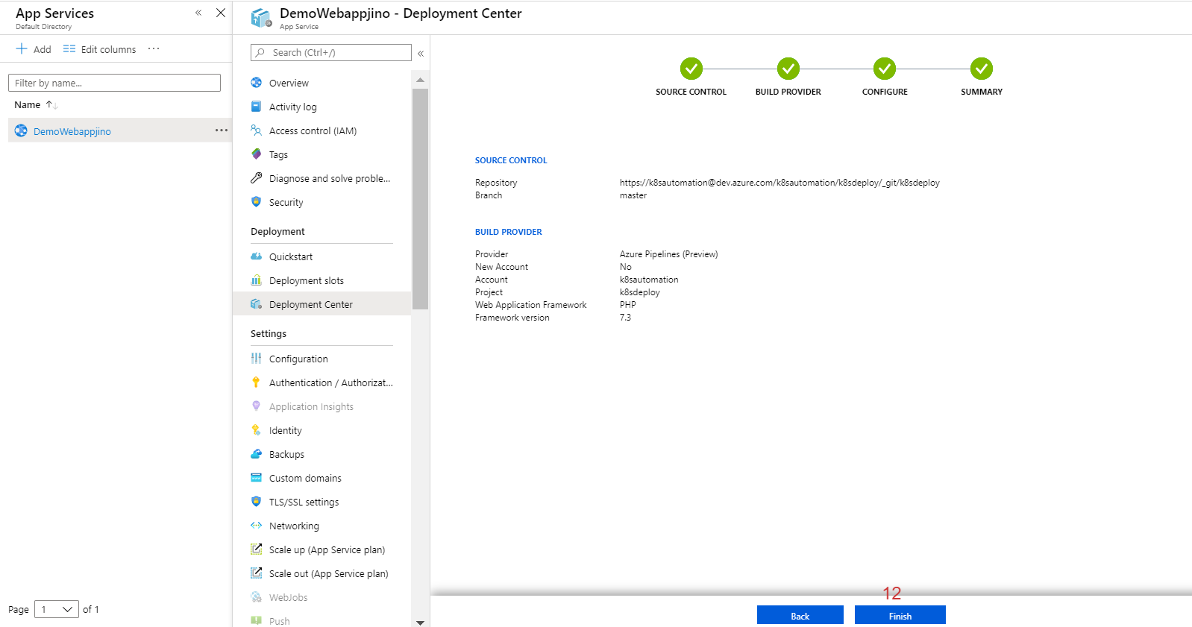

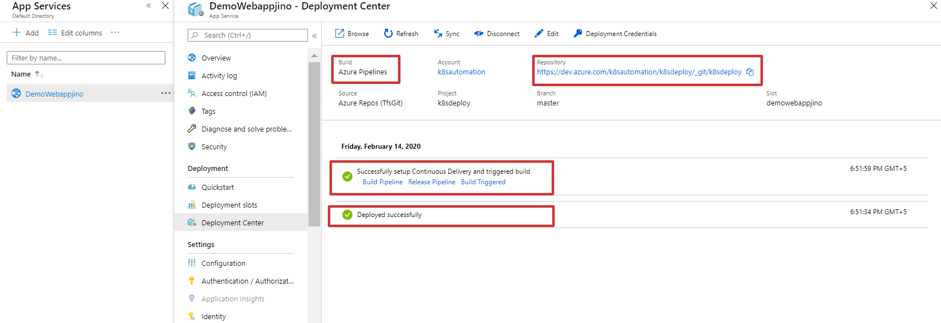

Deployment done.



Traffic manager

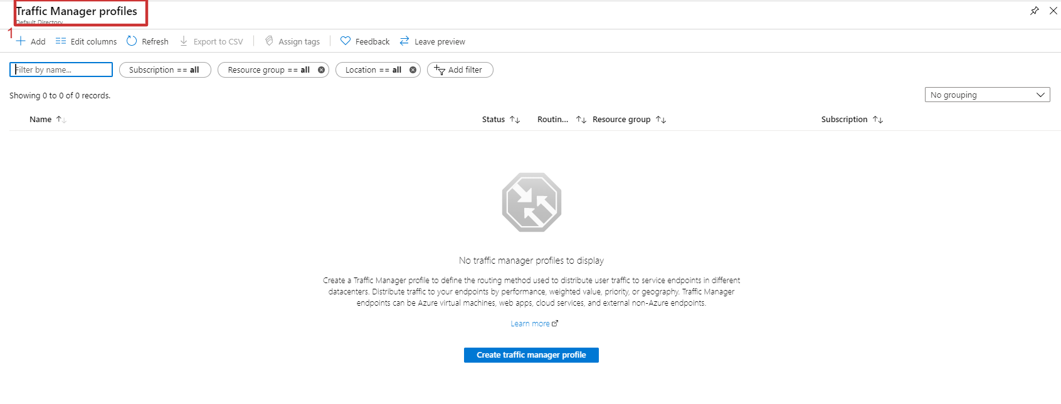

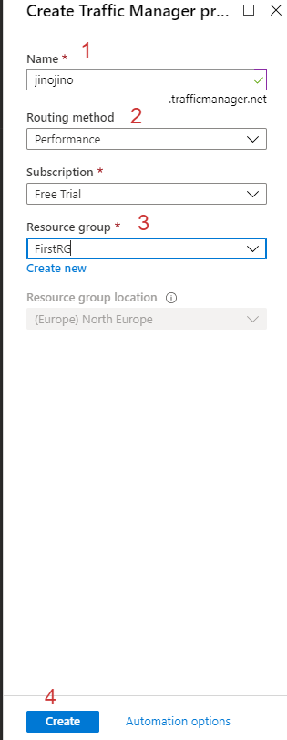

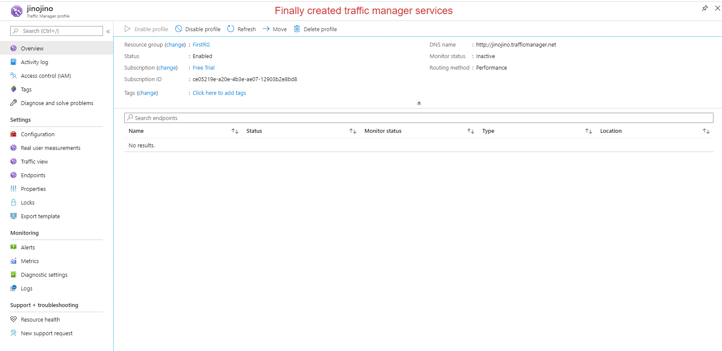

Added endpoint connection into traffic manager

